Official league roster – Basketball

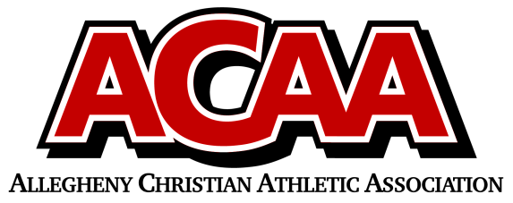

SCHOOL NAME: BELLEVILLE MENNONITE HEAD COACH: CHASE PEACHEY
OPPONENT: ________________________________ ASST. COACH: MICHAEL AMMON DATE: __________

Number | Name | Year | Position | Height
14 | Evan Crosson | 12
2 | Drew Miriello | 12
11 | Quinn Renno | 12
12 | Clay Ammon | 11
21 | Miguel Interiano | 11
31 | Paul Yoder | 11
42 | Dakota Gibbons | 10
10 | Bryson Peachey | 10
51 | Collin Hartzler | 9
52 | Ethan Renno | 9
54 | Grant Yoder | 9

OFFICIAL ACAA LEAGUE TEAM ROSTER - TO BE SUBMITTED TO THE SCORER’S TABLE BEFORE EACH GAME.

